

**INVENTORY MANAGEMENT & CUSTOMER MANAGEMENT SYSTEM**

**BY**

**SAİT POSTACI 17030411003**

**ANKARA YILDIRIM BEYAZIT UNIVERSITY BUSINESS SCHOOL**

**FALL 2020**

Contents

INTRODUCTION 3

Purpose Of The Project 3

Goal of the project 3

System Architecture 3

Screenshots from system 4

Main page 4

Customer page 4

Adding customers 5

Products page 5

Adding new product 5

Lesser quantity page 6

Database tables 6

# INTRODUCTION

For this semester’s school project I have been assigned a task to build a working application that will usefull for daily routine in any particular topic.The idea was up to me to.I started to do some research for a couple days but I could not find any idea that would be usefull.After some time I realized that I was thinking so hard to find an idea.I decided to think more simple and narrow the area for the idea.I started to think about my daily life.What am I doing in a day, what can I do to make a particular task easy to do.I am spending most of the day at our family business.I wrote down all of my tasks that I am doing at work. I eliminate some of the tasks from that list.At the end there was 2 task which could be done much more easy with a system.Those task were to track current inventory and manage the orders have been given by customers.Therefore I decided to build a system which I can track both tasks in a simpler way.

## Purpose Of The Project

Main purpose of this system is to record the data of inventory and customer information to a computer.Therefore it would be much more easy to manage both inventory and customer from one application.before that those records was being kept in a notebook.By doing that here is aim is to record those information in an organized way.

## Goal of the project

Main goal of this project is to save time and avoid complexity to find records for the business.

# System Architecture

This system will only work on one computer.There will be no need to hire an outside server to reach the application.All data will be stored in local server.Apllication written in php and as database system uses phpMyAdmin software.There will be total 7 pages including main page

# Screenshots from system

## Main page

In order to have an easy control on system main page kept simple

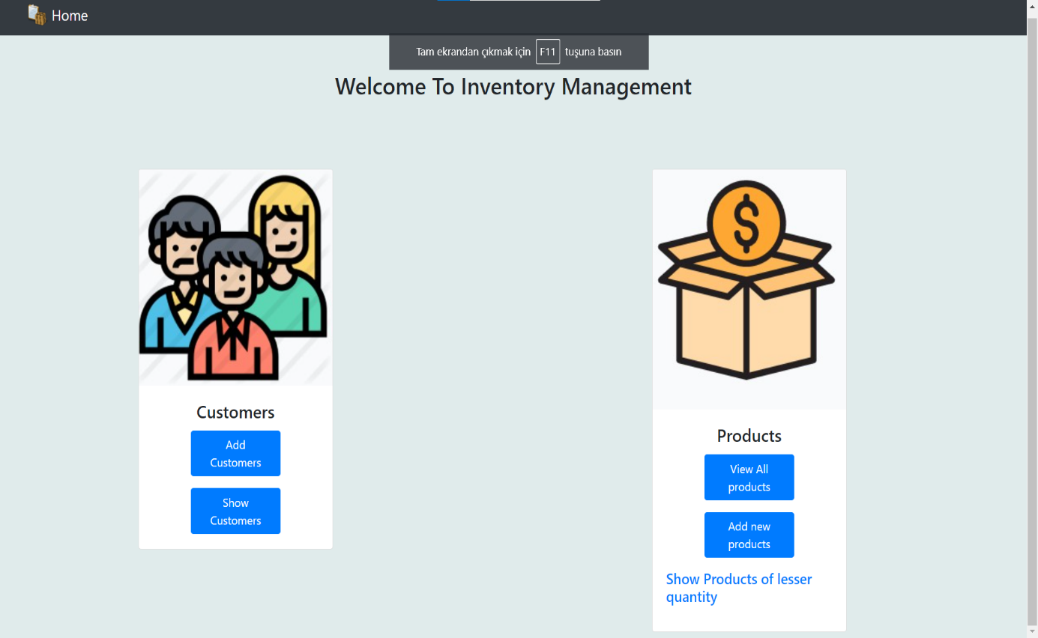

## Customer page

In this page system will keep the information of customer such as adress phone number gender etc

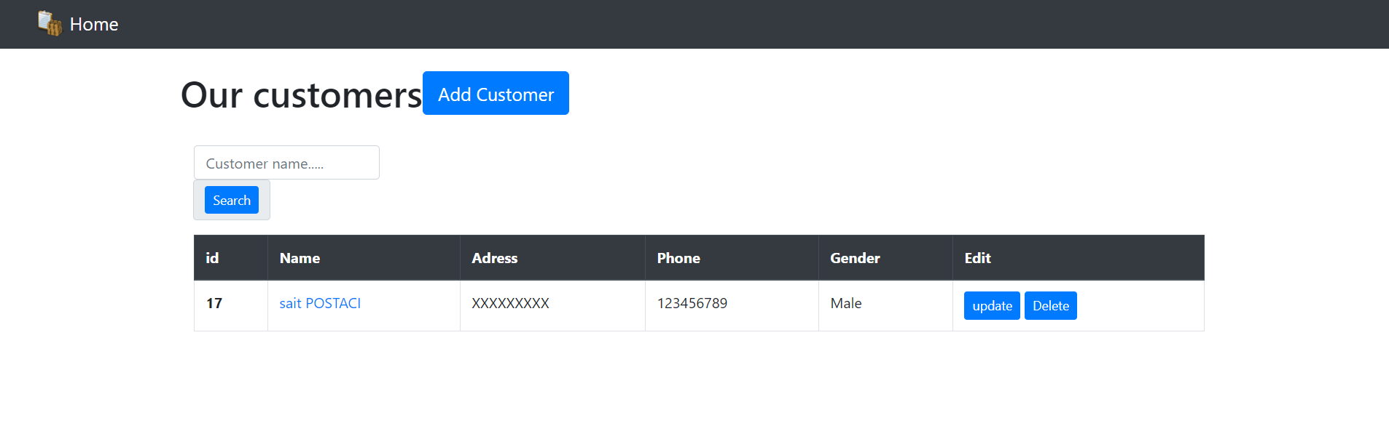

## Adding customers

In this page we can register the information of customers

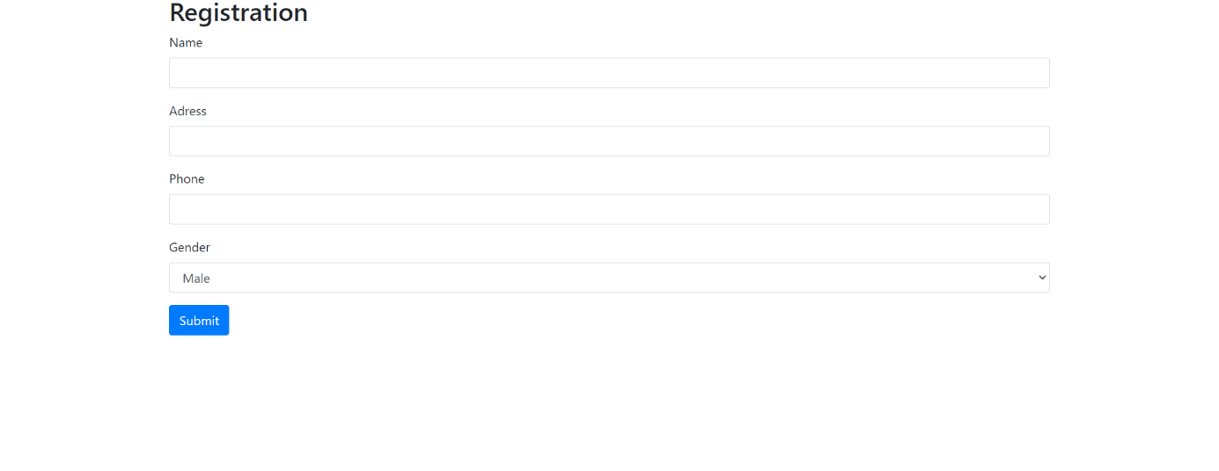

## Products page

In this page we will hold the information of our inventory.

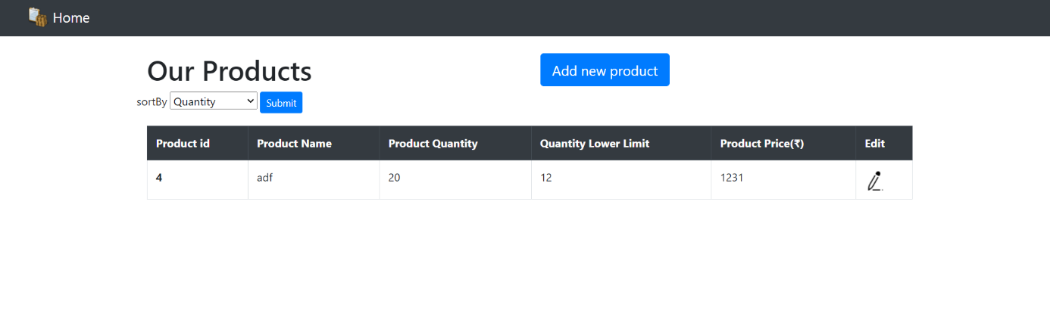

## Adding new product

In this page we can add new product to the inventory

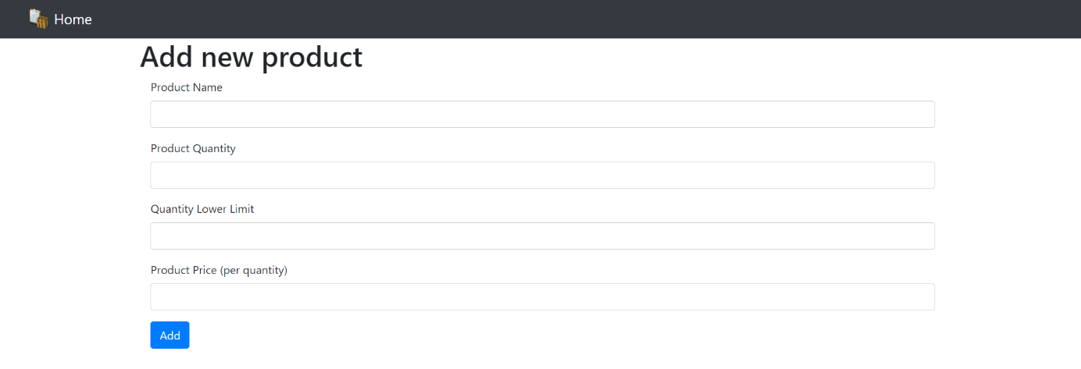

## Lesser quantity page

In this page we can see which product is under the quantity that defined at the adding product page.By creating a page like that we can see which product needed to ordered

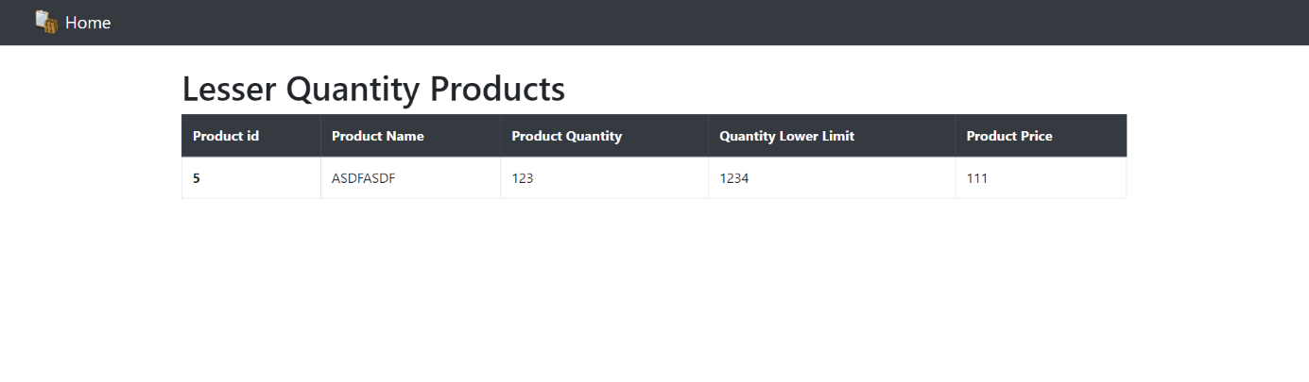

## Database tables

There will be only 2 tables in the system one is for customer and the other for the products

